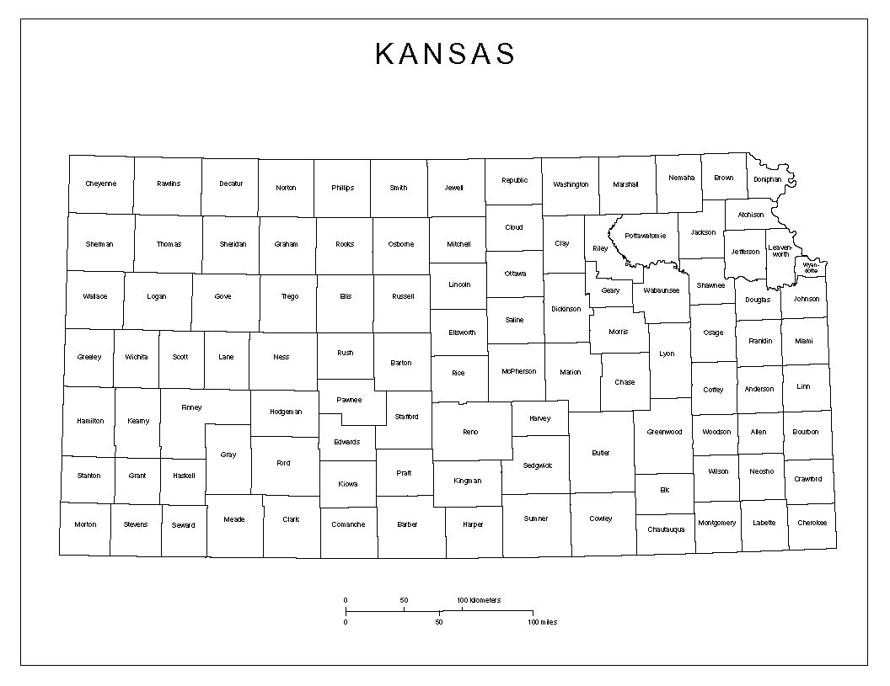

**Shelli Nyambane, SE KS**

**620-860-7240**

**Aaron Lovelady, Wichita Area**

**316-337-6012**

**316-337-6012**

**Justine Culver, KC Metro**

**785-330-8607**

**Abby Cooper, NC KS**

**785-515-6710**

**Working Healthy Benefits Specialist Regional Map**

**Danielle Mowery, W KS**

**620-682-7945**

**Earl Williams, NE KS**

**785-330-8602**

**Billie Crawshaw, Senior Manager 785-261-6122**

**Sarah Guardado, SC Kansas**

**316-337-6409**